<<COURT_NAME>>

|  |  |
| --- | --- |
| <<PROVIDER_SUITNAME>>,  a/a/o <<INJUREDPARTY_NAME>>    Plaintiff,  vs.  <<INSURANCECOMPANY_SUITNAME>>  Defendant. | Case No. <<INDEXORAAA_NUMBER>> |

__________________________________________/

**PLAINTIFF’S MOTION TO COMPEL ANSWER TO COMPLAINT**

The Plaintiff, <<PROVIDER_SUITNAME>>, by and through the undersigned counsel, moves this Court for entry of an Order compelling Defendant, <<INSURANCECOMPANY_SUITNAME>>, to file an answer within 10 days and, as grounds therefore states:

A Complaint was filed in this matter under the above-captioned case and was properly served on Defendant as per the court docket a few days later.

To date the Defendant has failed to Answer the Complaint.

3. In the interests of judicial expediency the Plaintiff would like to move this case forward and get a trial date as soon as possible, but is unable to do so without an Answer being filed.

4. Plaintiff believes that Defendant should be compelled to answer the complaint within 10 days.

**WHEREFORE**, the Plaintiffs respectfully request that the foregoing motion be granted in its entirety.

**CERTIFICATE OF SERVICE**

I HEREBY CERTIFY that on February 19, 2022, a true and correct copy of the foregoing was filed and served on the Defendant through Florida Courts E-Filing Portal.

**Florida Insurance Law Group, LLC**

8724 Sunset Drive, #260, Miami, FL 33173

Tel. (305) 906-4262

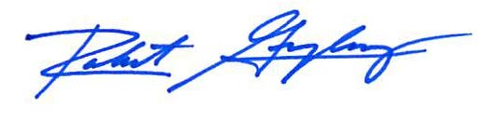

Robert F. Gonzalez, Esq.

Fla. Bar No. 68865

Pleadings@flinslaw.com